JSON Refiner Advanced Edition
Degree of Bachelor of computer science in
Manonmaniam Sundaranar University, Tirunelveli.
Submitted by
ABIJITH A S(23083011802111002)
RIMON SANTHOSH S(23083011802111033)
BHARATH M A(23083011802111019)
ABISH A(23083011802111005)

ROHITH J(23083011802111034)

DEPARTMENT OF COMPUTER SCIENCE ANNAI VELANKANNI COLLEGE
Accredited with ‘A’ Grade by NAAC (II Cycle)
(AFFILIATED TO MANONMANIAM SUNDARANAR UNIVERSITY, TIRUNELVELI) THOLAYAVATTAM-629157
KANYAKUMARI DISTRICT, TAMILNADU Ph:9486935270
Website: www.annaicollege.edu.in (2025-2026)

JSON Refiner Advanced Edition

Project Description

JSON Refiner – Advanced Edition (Description)
JSON Refiner – Advanced Edition is an advanced software tool designed to analyze, validate, clean, transform, and optimize JSON (JavaScript Object Notation) data. It help developers, data engineers, and analysts work efficiently with complex JSON structures by providing powerful tools for formatting, restructuring, filtering, and validating JSON files.
The tool simplifies the process of handling large or unstructured JSON datasets by automatically detecting errors, improving readability, and converting data into a well-organized structure. It supports advanced operations such as schema validation, nested data transformation, key renaming, type conversion, and data extraction, making it useful in API development, data pipelines, and system integrations.
JSON Refiner – Advanced Edition typically includes features like syntax highlighting, tree and table views, bulk processing, JSON comparison, and export options to formats such as XML, CSV, or YAML. These capabilities allow users to quickly debug API responses, restructure configuration files, and prepare data for analytics or application use.
Overall, JSON Refiner – Advanced Edition improves productivity by reducing manual data cleaning and ensuring that JSON data remains accurate, structured, and ready for integration with modern software systems.

Scenarios
Scenario 1:
Instant Text Formatting
Instant Text Formatting is a feature or tool that automatically cleans, organizes, and formats text immediately after it is entered or pasted. It helps convert raw or unstructured text into a clear, readable, and properly structured format without requiring manual editing.
This feature is commonly used in text editors, coding environments, data processing tools, and content management systems to improve readability and maintain consistent formatting standards.

Scenario 2:
Responsive Layout Adjustments
Responsive Layout Adjustments refer to the process of automatically adapting a user interface or webpage layout so that it displays properly across different screen sizes, devices, and orientations. This ensures that content remains readable, functional, and visually appealing whether viewed on a smartphone, tablet, laptop, or desktop computer.
Responsive design techniques allow elements such as text, images, menus, and containers to dynamically resize, reposition, or reorganize based on the screen dimensions and resolution. This creates a consistent and user-friendly experience across all devices.

Scenario 3:
Interactive Button Styling
Interactive Button Styling refers to designing and implementing buttons that visually respond to user actions such as hovering, clicking, focusing, or tapping. These dynamic style changes help users understand that a button is interactive and provide immediate visual feedback during interaction.
Interactive button styling is commonly used in websites, mobile applications, and user interfaces to enhance usability, accessibility, and overall user experience.
]

Scenario 4:
Table & Form Customization
A data analyst is embedding tables and forms in a dashboard and needs to make them visually appealing.
- The tool allows adjusting table borders, header colors, row striping, input field sizes, and form alignment.
- Generates inline CSS or classes that can be reused across multiple tables or forms.
- Example: A table with alternating row colors and rounded form input fields for a clean dashboard look
Scenario 5:
Theme & Component Preview
A developer is building a small website and wants to test different color schemes and component styles before finalizing the design.
- The HTML Quick Styler provides a live preview panel where multiple themes can be applied to headers, buttons, and sections.
- Users can export the generated CSS or <style> blocks directly for integration.
- Example: Switching a site’s theme from light to dark mode with one click and seeing instant changes across all components.

Architecture Overview
The HTML Quick Styler is designed as a modular, user-friendly tool that allows users to rapidly style HTML elements without writing full CSS manually. At its core, the system consists of a front-end interface with an HTML editor, live preview, and a styling panel where users can adjust colors, fonts, spacing, borders, and other visual properties. A styling engine dynamically converts these UI selections into valid CSS and applies them instantly to the elements, while an optional template library provides pre-designed components for faster development. The tool also supports persistence and export, allowing users to save their styled HTML locally or to the cloud, and to generate inline CSS or separate CSS files. For more advanced functionality, a backend can handle user authentication, reusable templates, and versioning. This architecture ensures rapid visual feedback, flexibility in styling, and seamless integration of reusable design elements.

Core Technologies

1.Front-End Technologies
- HTML5 & CSS3 – Base structure and styling of the editor and preview interface.
- JavaScript (ES6+) – Core scripting for interactivity, dynamic styling, and DOM manipulation.
- UI Frameworks – Libraries like React, Vue, or Svelte to manage component state and live updates.
- Code Editing Libraries – CodeMirror or Monaco Editor for live HTML/CSS editing and syntax highlighting.
- UI Components / CSS Utilities – Optional frameworks like Tailwind CSS or Bootstrap to speed up styling of the interface.
2. Styling Engine
- CSS-in-JS libraries (optional, e.g., Styled Components for React) to map UI selections into CSS dynamically.
- Custom JavaScript modules to validate user input and apply styles to the preview pane.
3. Persistence & Export
- Browser Storage – LocalStorage or IndexedDB for saving user sessions.
- File Generation APIs – Blob/FileSaver.js for exporting HTML and CSS files.
4.Optional Back-End
- Node.js / Express – For user authentication, cloud storage, and serving reusable templates.
- Database – MongoDB or Firebase for storing templates and versioning user projects.
5. Additional Tools
- Color pickers, sliders, and font selectors implemented via JavaScript libraries.
- Drag-and-drop libraries for component placement, e.g., Interact.js or React DnD.

Pre-requisites
Software Requirements

To develop or use an HTML Quick Styler effectively, the following software must be available:
1.Web Browser
  - A modern browser that fully supports HTML5, CSS3, and JavaScript ES6+.
  - Recommended: Google Chrome, Mozilla Firefox, or Microsoft Edge.
2.Code Editor / IDE
  - For development: Visual Studio Code, WebStorm, or any editor that supports HTML, CSS, and JavaScript.
  - Optional plugins for syntax highlighting, linting, and live server preview.
3.Package Manager / Build Tools
  - Node.js with npm or yarn to manage dependencies and run local servers.
  - Build tools like Webpack, Vite, or Parcel if using modern front-end frameworks.
4.Libraries & Frameworks
  - Front-end frameworks: React, Vue, or Svelte (depending on chosen architecture).
  - Styling libraries: Tailwind CSS, Bootstrap, or optional CSS-in-JS tools.
  - Code editor libraries: CodeMirror or Monaco Editor for live HTML/CSS editing.
5.Optional Backend Software
  - Node.js / Express for handling cloud storage, authentication, and template management.
  - Database: MongoDB, Firebase, or other cloud databases for saving user projects.
6.Utilities & Plugins
  - Color pickers, sliders, and drag-and-drop libraries for interactive styling (e.g., Interact.js, React DnD).
  - File generation tools like FileSaver.js for exporting HTML and CSS.
Knowledge Prerequisites
To effectively use or develop an HTML Quick Styler, the following knowledge areas are essential:
1. HTML & CSS
- Understanding of HTML elements, attributes, and semantic structure.
- Knowledge of CSS properties, selectors, layout techniques (Flexbox, Grid), and styling rules.
- Familiarity with inline, internal, and external CSS application.
2. JavaScript Fundamentals
- DOM manipulation, event handling, and dynamic content updates.
- Knowledge of ES6+ syntax and modern JavaScript features.
- Experience with JavaScript libraries for UI interactions.
3. Front-End Frameworks (Optional for Developers)
- Familiarity with frameworks like React, Vue, or Svelte for building dynamic interfaces.
- Understanding of component-based architecture and state management.
4. Version Control & Development Workflow
- Basic Git commands for tracking changes and collaborating on code.
- Understanding of npm/yarn package management for dependencies.
5. Optional Back-End Knowledge
- Node.js and Express basics for server-side functionality (cloud saving, template storage).
- Basic database concepts if persisting user projects or templates.
6. UI/UX Awareness
- Understanding how design choices (color, typography, spacing) affect usability.
- Knowledge of responsive design principles for preview and export.

1.Hardware Requirements
To ensure smooth operation and development of an HTML Quick Styler, the following hardware specifications are recommended:
- Processor (CPU)
  - Minimum: Dual-core processor, 2.0 GHz or higher.
  - Recommended: Quad-core processor or better for faster rendering and live previews.
- Memory (RAM)
  - Minimum: 4 GB RAM.
  - Recommended: 8 GB RAM or more for handling multiple browser tabs, editors, and live preview updates simultaneously.
- Storage
  - Minimum: 500 MB free disk space for application files and project storage.
  - Recommended: SSD storage for faster load and save operations.
- Graphics
  - Integrated graphics sufficient for rendering HTML and CSS previews.
  - Dedicated GPU optional but not required.
- Display
  - Minimum: 1366 × 768 resolution.
  - Recommended: Full HD (1920 × 1080) or higher for comfortable editing and previewing.
- Peripherals
  - Keyboard and mouse for editing and styling controls.
  - Optional: Multi-monitor setup for improved productivity when editing and previewing simultaneously.

2. Multi-Style Docstring Support
- Enables developers to write docstrings in different formats according to their preference or team standards.
- Improves readability, maintainability, and auto-generation of documentation.
- Facilitates integration with tools like IDEs, linters, or documentation generators that may support specific docstring styles.
3. IDE Integration
Create plugins for popular development environments.
Possible IDE integrations
VS Code Extension
PyCharm Plugin
Jupyter Notebook integration
Features:
Auto generate docstring with shortcut
Real-time documentation suggestions

4. Automatic Code Example Generation
Doc_Genie can generate usage examples for functions.
Example:
result = add_numbers(5, 3)
print(result) # Output:
Benefit:
Helps beginners understand the function quickly.

5. Documentation Quality Analyzer
Add a module to evaluate documentation quality.
Checks may include:
Missing parameter descriptions
Incomplete return descriptions
Poor naming conventions
Benefit:
Improves code quality during code reviews.

6. Batch Project Analysis
Allow Doc_Genie to scan an entire project folder.
Features:
Analyze multiple Python files
Generate docstrings automatically
Create documentation reports

7. Documentation Coverage Report
Add a coverage system similar to test coverage.
Example output:
Total Functions: 120
Documented: 85
Missing Docstrings: 35
Coverage: 70%
8. Web Dashboard Interface
Develop a web-based UI for documentation management.
Features:
Upload Python files
Generate docstrings
Edit generated documentation
Export documentation
Possible tools:
Gradio
Streamlit
Flask

9. CI/CD Integration
Integrate Doc_Genie with DevOps pipelines.
Examples:
GitHub Actions
GitLab CI
Jenkins
Purpose
Automatically check documentation during builds.
10. Multi-Language Support
Extend the tool to support additional programming languages.
Future support:
Java
JavaScript
C++
Go
11. Visualization of Function Structure
Create AST visualizations.
Example:
Function dependency graphs
Call hierarchy diagrams
Libraries:
Graphviz
NetworkX
12. Documentation Export System
Allow exporting documentation to different formats.
Formats:
PDF
HTML
Markdown
API documentation
Tools:
Sphinx
MkDocs

Create requirements.txt with the following dependencies:

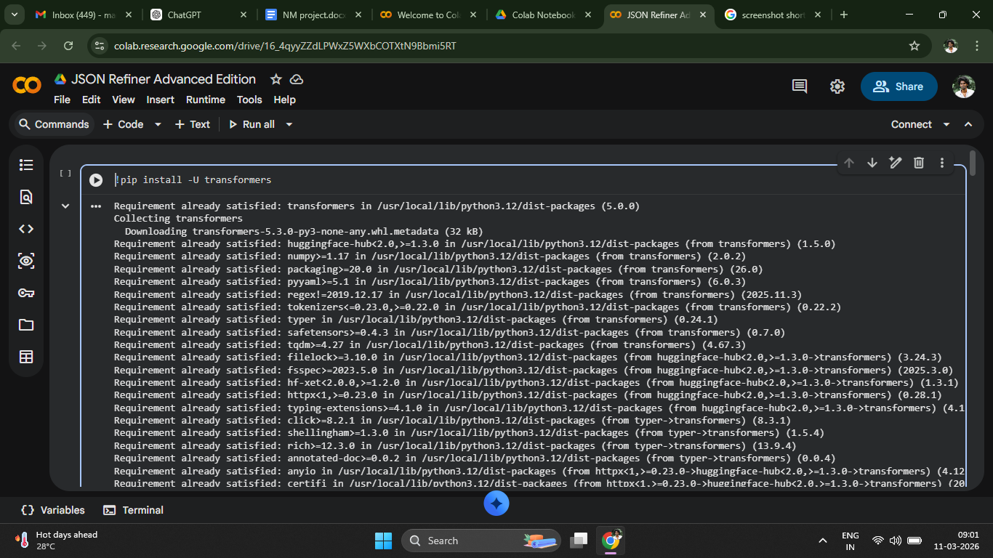
Instialize core analyzer class:

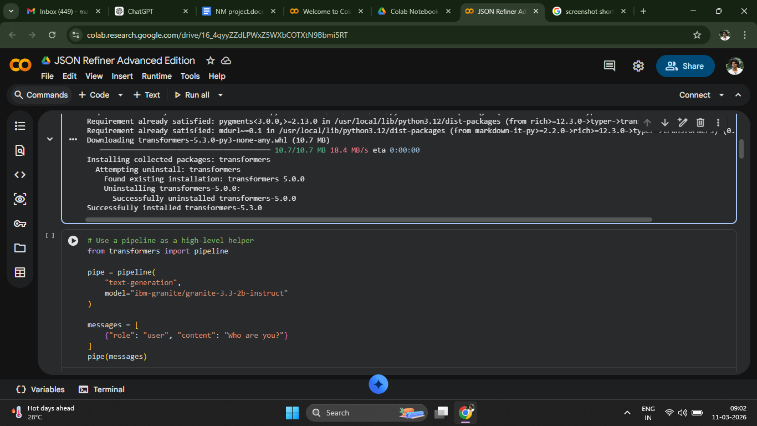
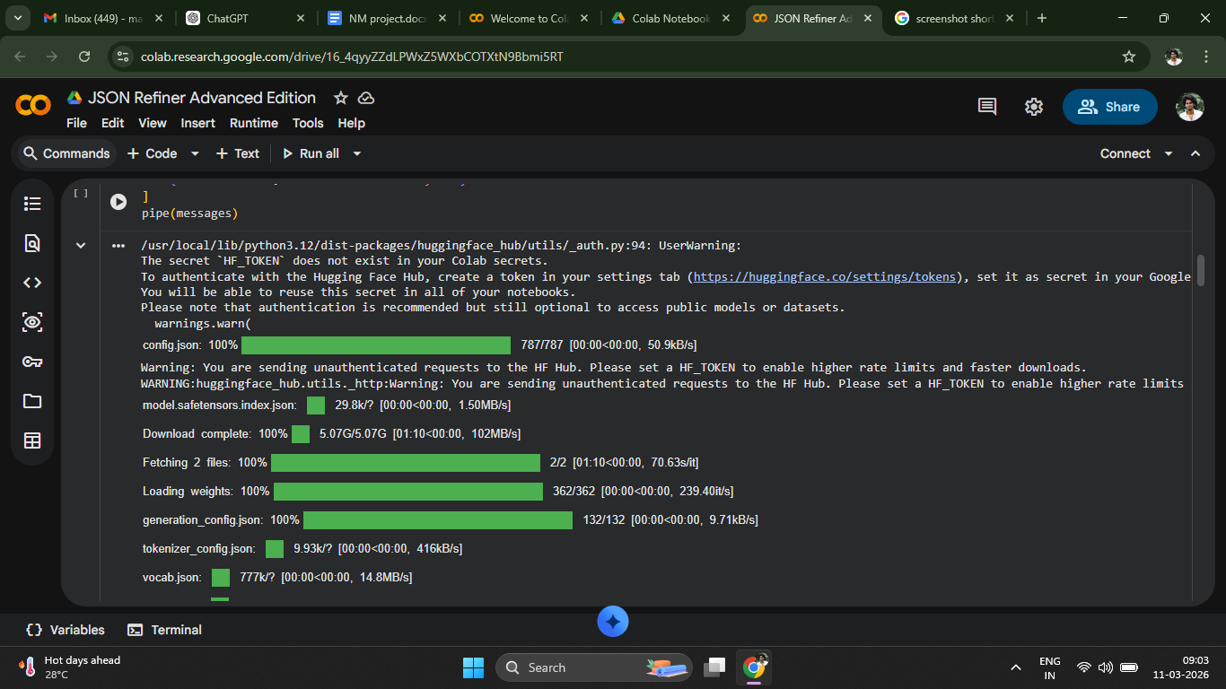
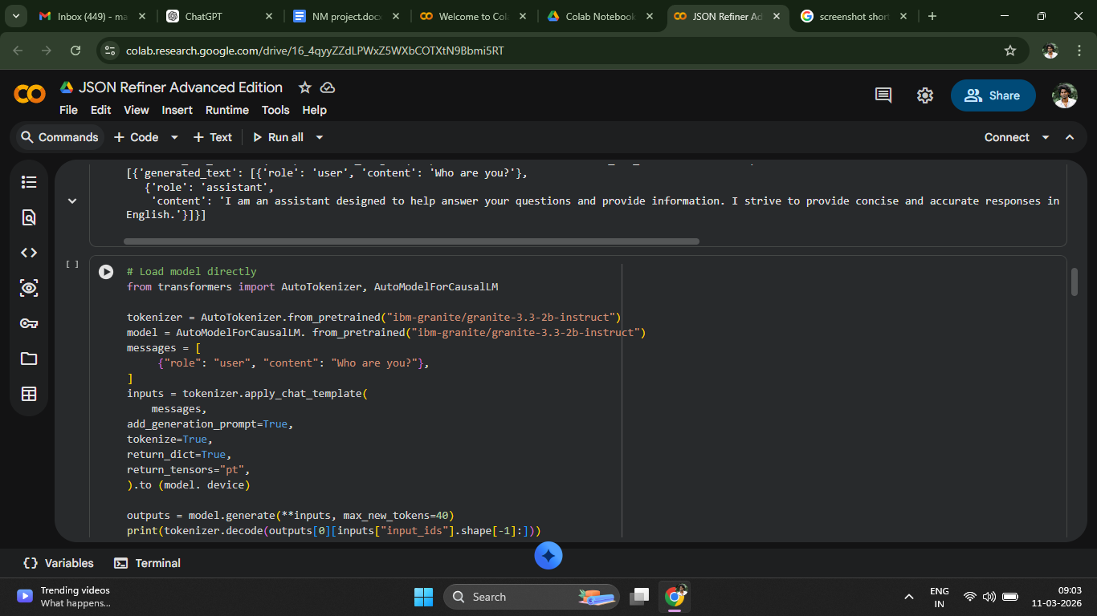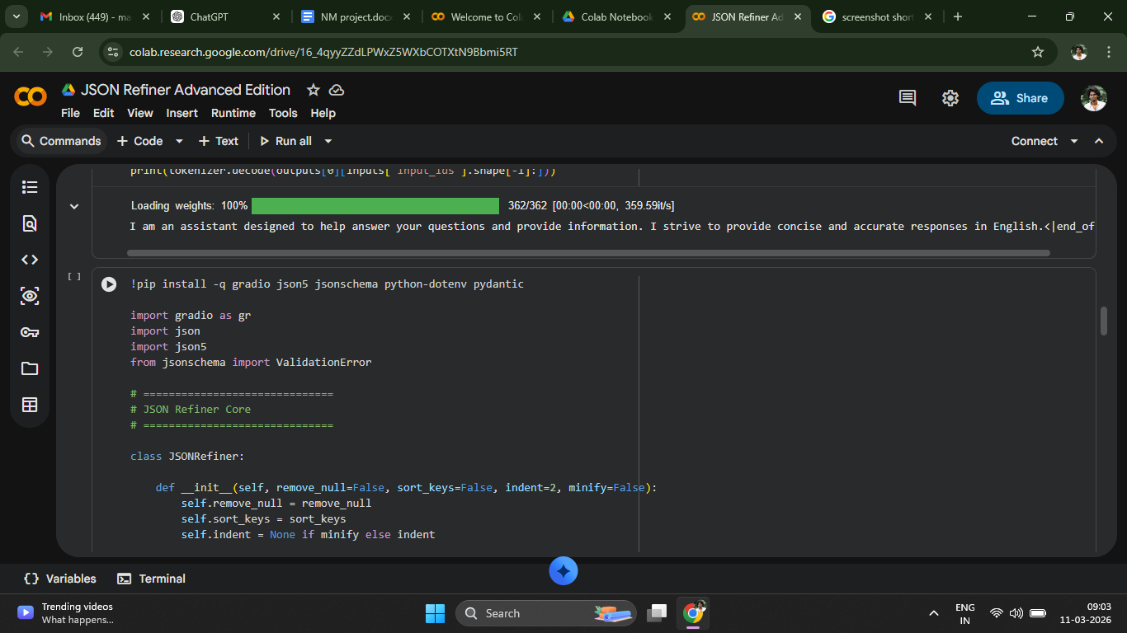

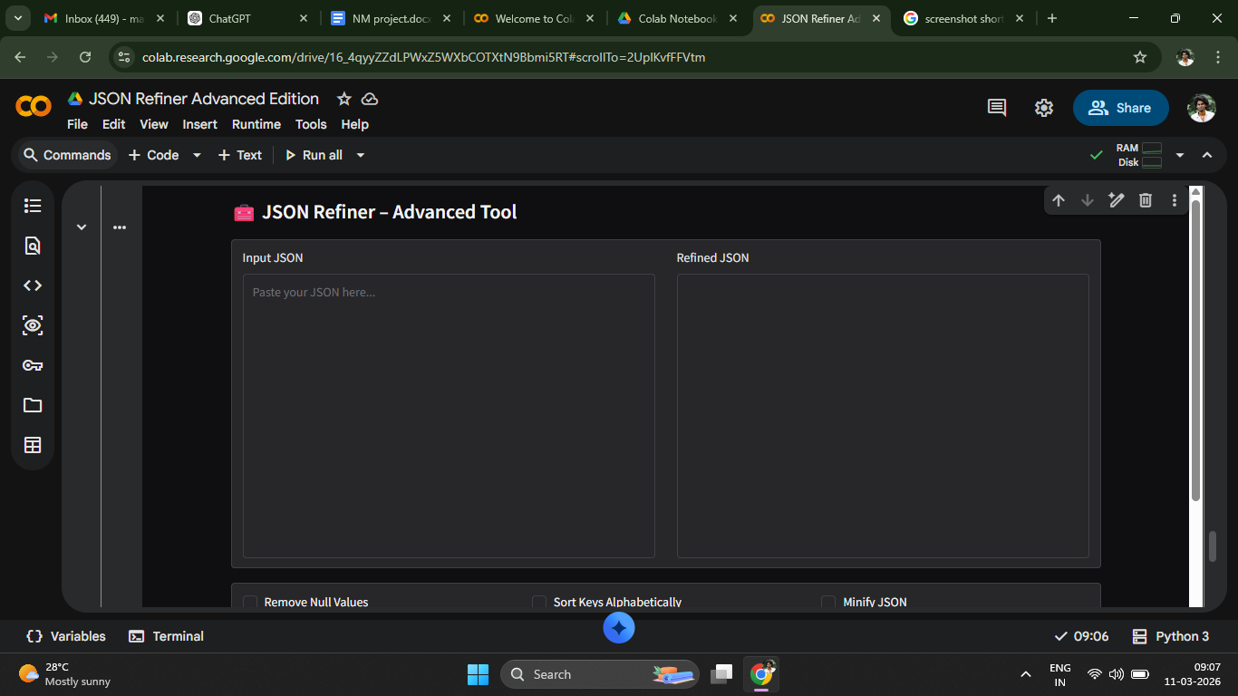

Future Enhancement:
Future Enhancements refer to planned improvements or additional features that can be added to the system in later versions to make it more powerful, efficient, and user-friendly. These enhancements help expand the functionality of the application and improve the overall user experience.
For a system like JSON Refiner – Advanced Edition, several future improvements can be considered to make the tool more advanced and versatile.

Conclusion
The JSON Refiner – Advanced Edition provides an efficient solution for managing and improving JSON data. It simplifies the process of formatting, validating, and transforming JSON structures, making it easier for developers and data professionals to work with

